OCCTAC FALL REGISTRATION NOW OPEN!
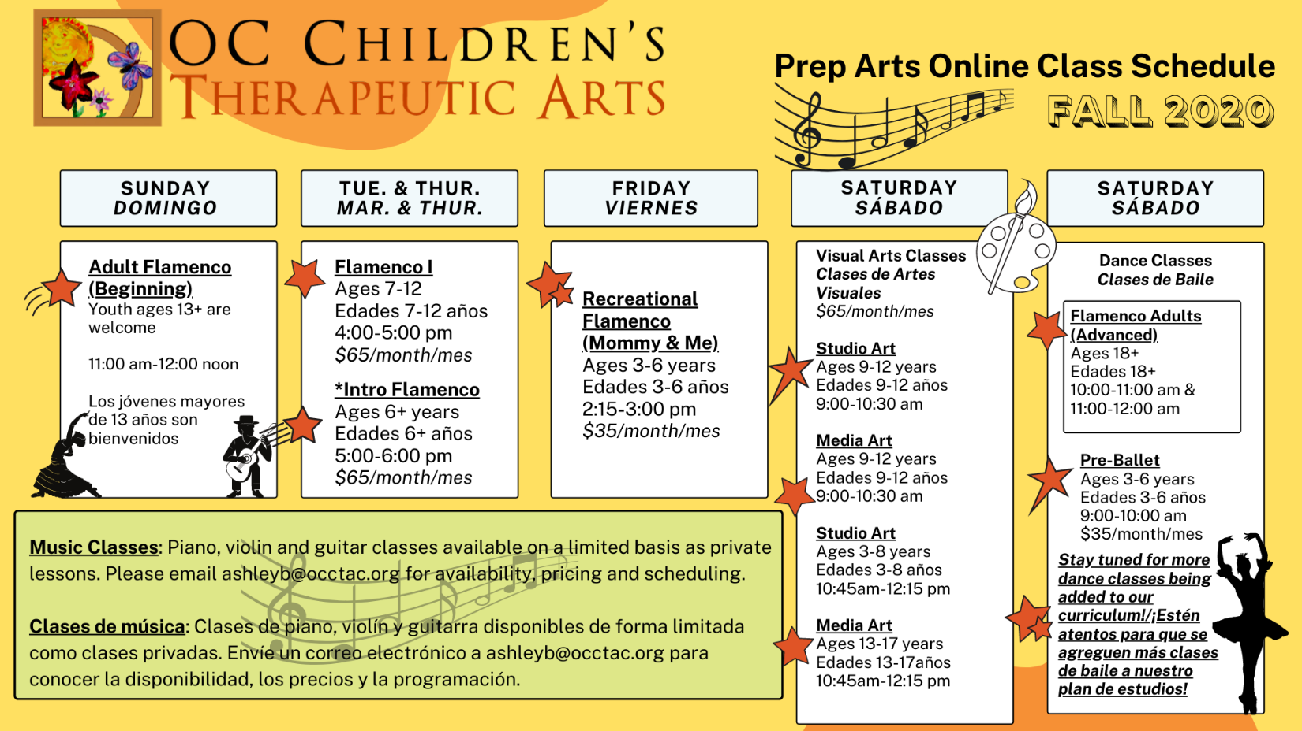
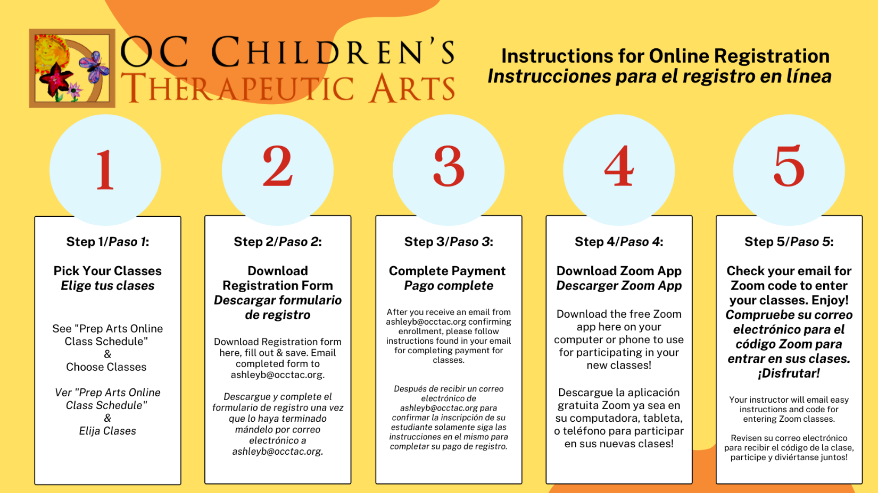
2215 N. BROADWAY, SANTA ANA, CA 92706 (714)547-5468
OCCTAC FALL REGISTRATION NOW OPEN!

2215 N. BROADWAY, SANTA ANA, CA 92706 (714)547-5468

